How to practice linux in WINDOWS

Click on windows button



Enter Turn windows

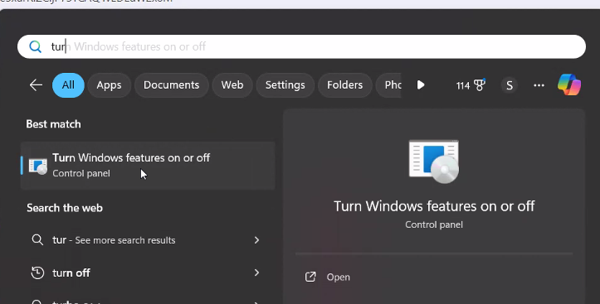

Click on open



Check out windows subsystem for linux

Now restart the system

Enter powershell in search box



Run as administrator

Now type

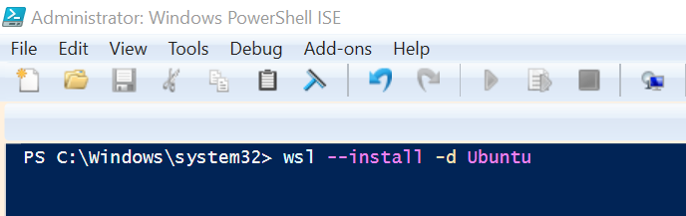

Wait for some time 100 percent to complete this will install ubuntu in your system

In search box you can check ubuntu

It should be downloading in your system

Once it is downloaded

Open it

Give the user name and password for normal user remember this

If you want to install a different Linux distribution, you can use wsl --list --online

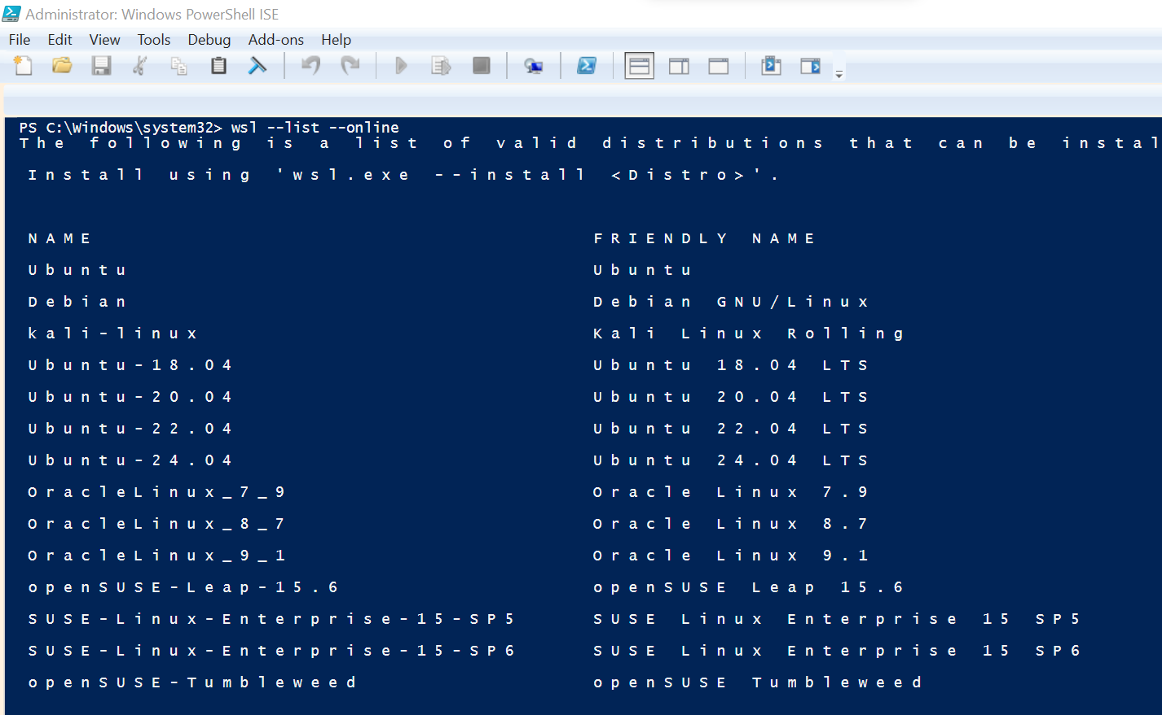

to see the available distributions and install one by specifying its name. For example:

wsl --install -d Debian